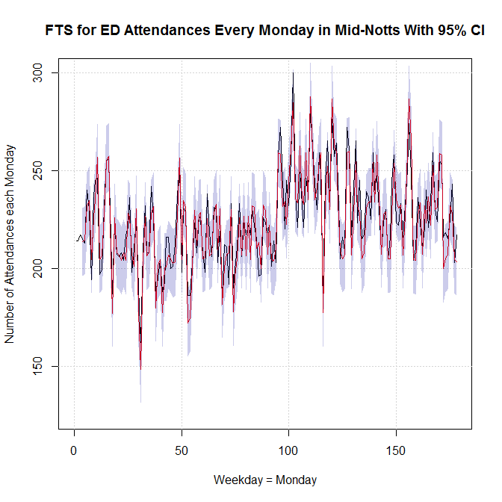

**R code for getting the predictions and plotting**

**# Required libraries**

library('forecastHybrid');

library(hybridModels);

library('forecast');

library(TTR);

library(MASS);

library(mgcv);

library(nlme);

library(TSA);

library(AnalyzeTS);

library(dplyr);

library(lubridate)

library('forecast');

library(MASS);

**# Read the data. Set the folder.**

library(readxl);setwd('C:/Users/msztaj/Desktop/EMAHSN- Projects/ED Predictor/Pui-Shan data')

PS_data <- read_excel("PSdata.xlsx", sheet = "sheetname");

attach(PS_data); names(PS_data)

**# Getting monthly data from daily values**

PS_monthly = tapply(PS_data$RK5BCED, week(PS_data$date), sum)

monthwise <- PS_monthly[1:52]

monthwise = t(monthwise); # converting row vector to column vector

PS_yearly = tapply(PS_data$RK5BCED, year(PS_data$date), sum)

monthwise = as.data.frame(monthwise)

monthwise =as.ts(monthwise[1:52,])

# As each year the admissions are different from the others, so taking proportion of total is better

#boxplot(RK5BCED ~ PS_data$Month, main="Month Wise ED Attendances in All Commissioners", xlab="Months",ylab= "Number of ED Attdendances")

#=================================================================================

**# Converting numeric to time series object**

a <- as.ts(monthwise); ts.plot(a) # checking the time series

LMon <- length(monthwise); print(LMon)

**# How many weekdays to predict. Best is 1, 2 or 3. Or number of months to predict**

Forecast4 = 6

**# Splitting into training and testing dataset.**

LL_trainMon <- LMon - Forecast4; LL_testMon <- LL_trainMon + 1 monthwise_train <- monthwise[1:LL_trainMon]; length(monthwise_train)

monthwise_test <- monthwise[LL_testMon:LMon]; length(monthwise_test);

sdMondays <- round(sd(monthwise_train))

#=================================================================================**# Monday - Fuzzy Time Series Modelling**

#=================================================================================

ts_mon =time

ts_mon <- as.ts(ts_mon); ts_mon = round(ts_mon,0); # Remove decimals

D1_mon = min(ts_mon); D2_mon = max(ts_mon); summary(ts_mon);

singh_Mon <- fuzzy.ts1(series,n = 50, D1 = D1_mon, D2= D2_mon, type= "Singh", plot=FALSE, trace =TRUE)

rbind(singh_Mon$accuracy)

singh_Mon$accuracy

E_mon = round(monthwise_train - singh_Mon$table2$forecast,0);

FTS_MondayModel <- cbind(ts_mon,singh_Mon$table2$forecast,E_mon);

write.csv(FTS_MondayModel, 'C:/Users/msztaj/Desktop/EMAHSN- Projects/ED Predictor/EXCEL Files/Monthwise_MidNotts.csv')

#=================================================================================

# Monday - Next Day Prediction

#=================================================================================

# Alow is lower limit of each fuzzy set

Alow_Mon <- t(singh_Mon$table1$dow); Alow_Mon <-as.data.frame(Alow_Mon)

# Alow is upper limit of each fuzzy set

Ahigh_Mon <- t(singh_Mon$table1$up); Ahigh_Mon <-as.data.frame(Ahigh_Mon)

# A is the set of fuzzy numbers with both lower and upper values.

AMon <- rbind(Alow_Mon,Ahigh_Mon); UMon <-length(AMon)

# Forecast4 how many weeks. This variable was defined in the start.

Lagg = 6

a = LL_trainMon - Lagg; b = LL_trainMon; k=1; c = 0; d = 0;

for (i in a:b) {

for (j in 1:UMon) {

c[k] = which(monthwise_train[i] >= AMon[1,] & (monthwise_train[i] < AMon[2,]))

}

k = k + 1

}

FjsMon <- singh_Mon$table1$mid[c] ; wtsMon <- singh_Mon$table1$num[c]

Mon_nextday_prediction <- sum(FjsMon *wtsMon)/sum(wtsMon) # next Monday's prediction

e1Mon <- round(Mon_nextday_prediction - monthwise_test[1]); print(e1Mon) # Error in prediction

#=================================================================================# Monday - Next to next Day Prediction

#=================================================================================

Next2NextMondays <- c(monthwise_train, Mon_nextday_prediction) # Including the first week prediction into original data for 2 weeks ahead prediction.

L2Mon <-length(Next2NextMondays); print(L2Mon)

a2Mon = L2Mon - Forecast4 ; b2Mon = L2Mon ; k = 1; c = 0 ; d2Mon = 0;

for (i in a2Mon:b2Mon) {

for (j in 1:UMon) {

c[k] = which(Next2NextMondays[i] >= AMon[1,] & (Next2NextMondays[i] < AMon[2,]))

}

k = k+1

}

Fjs2 <- singh_Mon$table1$mid[c]; wts2 <- singh_Mon$table1$num[c]

nex2next_Monday_prediction <- sum(Fjs2 *wts2)/sum(wts2); print(nex2next_Monday_prediction)

e2Mon <- round(nex2next_Monday_prediction - monthwise_test[2]); print(e2Mon)

#=================================================================================

# Monday - Next to Next Day Prediction - lag = 3

#=================================================================================

Third2NextMonday <- c(Next2NextMondays,nex2next_Monday_prediction)

L3Mon <-length(Third2NextMonday); print(L3Mon)

a = L3Mon - Lagg; b = L3Mon ; k = 1; c = 0 ; d = 0;

for (i in a:b) {

for (j in 1:UMon) {

c[k] = which(Third2NextMonday[i] >= AMon[1,] & (Third2NextMonday[i] < AMon[2,]))

}

K = k +1

}

Fjs2 <- singh_Mon$table1$mid[c]; wts2 <- singh_Mon$table1$num[c]

Third2next_Monday_prediction <- sum(Fjs2 *wts2)/sum(wts2); print(Third2next_Monday_prediction)

e3Mon <- round(Third2next_Monday_prediction - monthwise_test[3]); print(e3Mon)

errorsMon <- round(c(e1Mon,e2Mon,e3Mon));

print('Errors in Prediction for next 3 days'); print(errorsMon, Quote =TRUE)

ForecastedMon <- errorsMon+monthwise_test

# ERRROS saved into one file

# @@@@@@@@@@@@@@@@@@@@@@@@@@

errorsMon <- round(c(e1Mon,e2Mon,e3Mon)); print(errorsMon);

errors_3weeks <- cbind(errorsMon)

write.csv(errors_3weeks,'C:/Users/msztaj/Desktop/EMAHSN- Projects/ED Predictor/EXCEL Files/FTSnext 3 week day forecasts.csv')

AllForecast_errors <- cbind(ForecastedMon,errorsMon)

write.csv(AllForecast_errors,'C:/Users/msztaj/Desktop/EMAHSN- Projects/ED Predictor/EXCEL Files/next 3 week day forecasts with errors.csv')

# @@@@@@@@@@@@@@@@@@@@@@@@@@@@@@@@@@@@@@@@@@@@

# MONDAY - Plotting Time Series with 95% Confidence Intervals and 13 week predictions with 95% #Prediction Intervals

# @@@@@@@@@@@@@@@@@@@@@@@@@@@@@@@@@@@@@@@@@@@@

jpeg("H9_monthwisegOOD.png");

dev.new(); plot.new();

monthwise_train_date <- monthwise$date[1:LL_trainMon] #Adjusting length of date column

#length(monthwise_train_date)

plot(singh_Mon$table2$forecast, main = "Fuzzy Time Series for A&E Attendances on Every Monday \n With 95% Confidence Interval"

,xlab = "Monday number", ylab = "Number of Attendances",

xlim = c(0,LL_trainMon), ylim = c(0, max(ts_mon)),

grid(10,10, lty = 6, col = "cornsilk2"))

grid()

lines(ts_mon); lines(singh_Mon$table2$forecast, col='red')

upper <- singh_Mon$table2$forecast + 1.96*sqrt(singh_Mon$accuracy[5]) # singh_Mon$accuracy = 36.55

lower <- singh_Mon$table2$forecast - 1.96*sqrt(singh_Mon$accuracy[5]) # fit_Monday$sigma2 = 36.55

polygon(c(time(monthwise_train_date),rev(time(monthwise_train_date))), c(upper,rev(lower)),

col=rgb(0,0,0.6,0.2), border=FALSE)

out <- (ts_mon < lower | ts_mon > upper)